**Project Design Phase-II**

**Data Flow Diagram & User Stories**

|  |  |
| --- | --- |
| Date | 26.june 2025 |
| Team ID | LTVIP2025TMID53135 |
| Project Name | LearnHUb:Your Center For Skill Enhancement |
| Maximum Marks | 4 Marks |

**Data Flow Diagrams:**

A Data Flow Diagram (DFD) is a traditional visual representation of the information flows within a system. A neat and clear DFD can depict the right amount of the system requirement graphically. It shows how data enters and leaves the system, what changes the information, and where data is stored.



Example: DFD Level 0 (Industry Standard)

**Example:** [**(Simplified)**](https://developer.ibm.com/patterns/visualize-unstructured-text/)

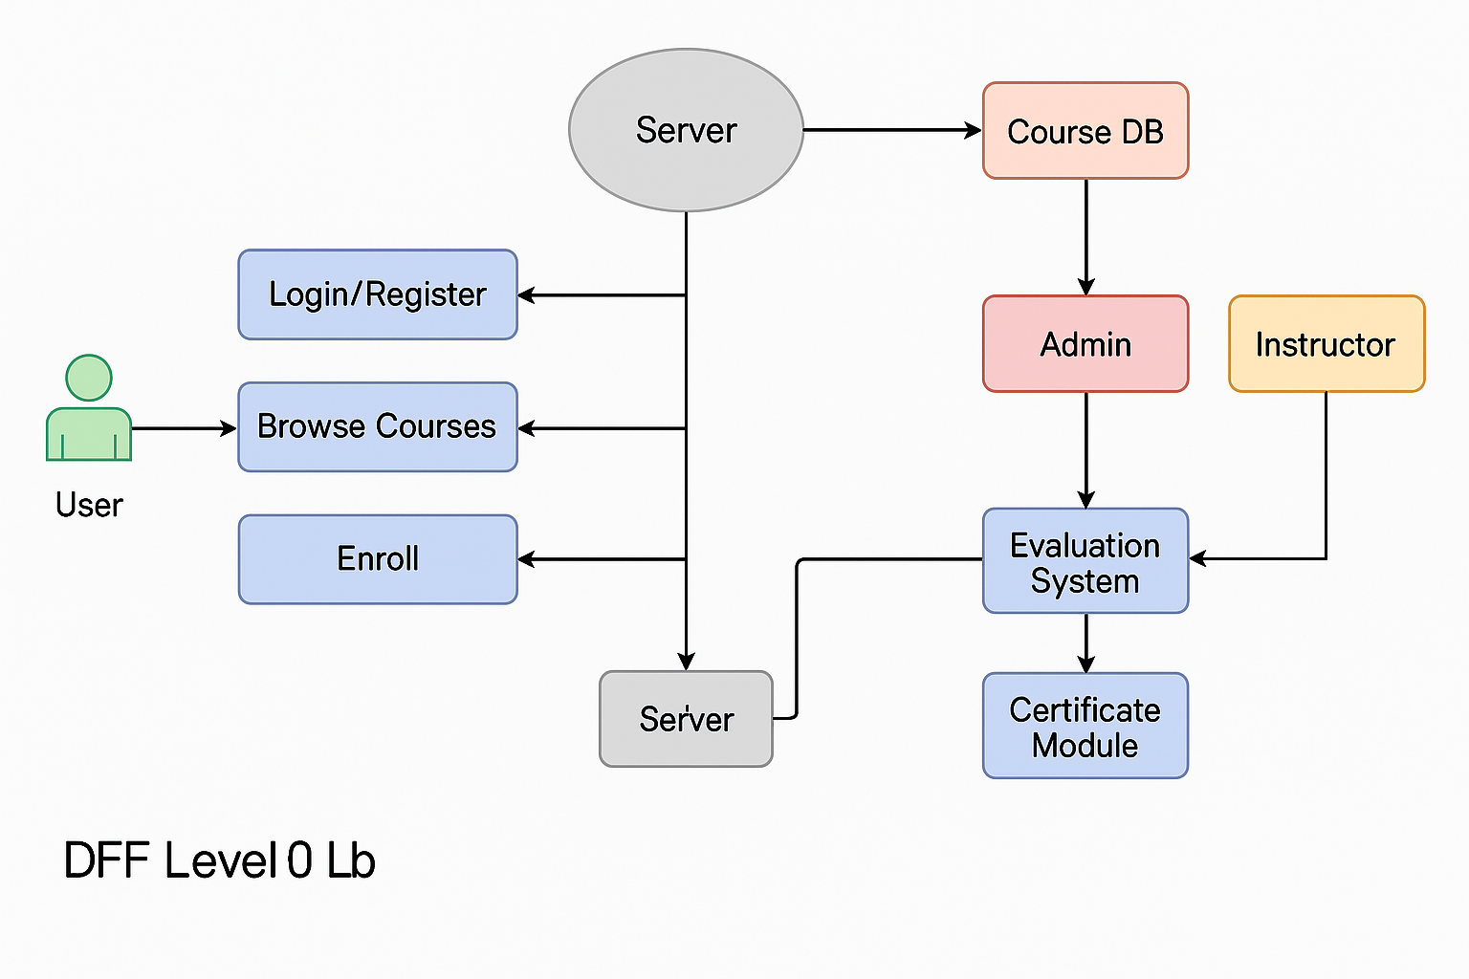

**DFD Level 0:**

* **User → Login/Register → Server**
* **User → Browse Courses → Course DB**
* **User → Enroll → Course DB**
* **User → Take Quiz → Evaluation System**
* **System → Generate Certificate → Certificate Module**
* **Instructor/Admin → Upload Course → DB**

**User Stories**

Use the below template to list all the user stories for the product.

|  |  |  |  |  |  |  |  |  |  |  |  |  |  |  |  |  |  |  |  |  |  |  |  |  |  |  |  |  |  |  |  |  |  |  |  |  |  |  |  |  |  |  |  |  |  |  |  |  |  |  |
| --- | --- | --- | --- | --- | --- | --- | --- | --- | --- | --- | --- | --- | --- | --- | --- | --- | --- | --- | --- | --- | --- | --- | --- | --- | --- | --- | --- | --- | --- | --- | --- | --- | --- | --- | --- | --- | --- | --- | --- | --- | --- | --- | --- | --- | --- | --- | --- | --- | --- | --- |
| | **User Stories (Sample Filled): User Type** | **Functional Requirement** | **User Story Number** | **Story** | **Acceptance Criteria** | **Priority** | **Release** | | --- | --- | --- | --- | --- | --- | --- | | Student | Registration | USN-1 | As a user, I can sign up with email/password | I see confirmation screen | High | Sprint-1 | | Student | Search Course | USN-2 | As a user, I can filter and browse courses | See filtered list | High | Sprint-1 | | Student | Enroll & Learn | USN-3 | As a user, I can enroll and access content | Video loads, progress tracked | High | Sprint-2 | | Student | Get Certificate | USN-4 | As a user, I get a certificate after completion | Certificate downloadable | Medium | Sprint-3 | | Instructor | Upload Course | USN-5 | As an instructor, I can add a course | Course appears in catalog | High | Sprint-2 | | Admin | Manage Users | USN-6 | As admin, I can manage user roles | Add/edit/delete users | Medium | Sprint-3 | |  |